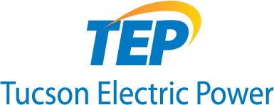
Program Process

Commercial Energy Solutions
EasySave Program

Step 1 – Program Overview and Facility Survey
Contractor visits customer and provides a short program overview and conducts a facility survey to identify energy savings opportunities.

Step 2 – Project Proposal
Contractor prepares a detailed proposal that includes expected savings, project costs, and the amount of rebate you’ll be eligible for. Customer reviews proposal and decides whether to proceed. Proposal is reviewed approved or not approved based on program specifications.

Step 3 –Confirmation
Customer eligibility is verified using customer-provided bills or TEP eligible customer list.

Step 4 – Pre-Installation Inspection
Customer provides access to the facility if a pre-installation inspection is required to ensure that all proposed measures are feasible and appropriate.

Step 5 – Measure Installation
Contractor schedules installation with the customer. Contractor performs the installation. Upon completion of the installation, contractor obtains the customer’s approval signature.

Step 6 – Post-Installation Inspection
A post-installation inspection may be required to verify that all measures were correctly installed. Any deficiencies will be resolved by the contractor.

Step 7 – Final Approval and Payment
Customer and contractor are notified that project is ready for rebate payment once deficiencies (if any) are corrected. Rebate will be paid directly to the contractor. Contractor will bill customer for the remaining balance of the project cost.

